LAB 3 TUTORIAL

This tutorial covers:
Chapter 4- Making Decisions (Selection Structures)

- Basic Multiple Choice and Subjective Question

- State the following statements whether it is True or False.

No | Statements | True/False
a. | The result of the logical expression cannot be assigned to an int variable. | F
b. | In a one-way selection, if a semicolon is placed after the expression in an if statement, the expression in the if statement is always true. | F
c. | Every if statement must have a corresponding else. | F
d. | The expression in the if statements:  if (score = 30)  grade = ‘A’;  always evaluate to true | T
e. | The expression:  (ch >= ‘A’ && ch <= ‘Z’)  evaluates to false if either ch < ‘A’ or ch >= ‘Z’. | F
h. | The expression !(x > 0) is true only if x is a negative number. | F

- Suppose that score is an int variable. Consider the following if statements:
if (score >= 90);
cout << “Discount = 10%” << endl;

a. What is the output if the value of score is 95? Justify your answer.
b. What is the output if the value of the score is 85? Justify your answer.

Answers:
a. The output is: Discount = 10%. The semicolon at the end of the if statement terminates the if statement. So the cout statement is not part of the if statement. The cout statement will execute regardless of whether the expression in the if statement evaluates to true or false.
b. The output is: Discount = 10%. The semicolon at the end of the if statement terminates the if statement. So the cout statement is not part of the if statement. The cout statement will execute regardless of whether the expression in the if statement evaluates to true or false.

- 1) Relational operators allow you to ________ numbers.
A) add
B) multiply
C) compare
D) average
Answer: C

- After execution of the following code, what will be the value of input_value if the value 0 is entered at the keyboard at run time?

cin >> input_value;
if (input_value > 5)
input_value = input_value + 5;
else if (input_value > 2)
input_value = input_value + 10;
else
input_value = input_value + 15;

A) 15
B) 10
C) 25
D) 0
E) 5
Answer: A

- What will be the output of the following code segment after the user enters 0 at the keyboard?

int x = -1;
cout << "Enter a 0 or a 1 from the keyboard: ";
cin >> x;
if (x)
cout << "true" << endl;
else
cout << "false" << endl;

A) Nothing will be displayed.
B) false
C) x
D) true
Answer: B

- If you place a semicolon after the statement:

if (x < y)

A) The code will not compile.
B) The compiler will interpret the semicolon as a null statement.
C) The if statement will always evaluate to false.
D) All of the above
E) None of these
Answer: B

- What is the output of the following code segment?

int x = 5;
if (x = 2)
cout << "This is true!" << endl;
else
cout << "This is false!" << endl;
cout << "This is all folks!" << endl;

A) This is true!
B) This is false!
C) This is true!
This is false!
D) This is true!
This is all folks!
Answer: D

- What is the output of the following segment of code if the value 4 is input by the user when asked to enter a number?

int num;
int total = 0;
cout << "Enter a number from 1 to 10: ";
cin >> num;
switch (num)
{
case 1:
case 2: total = 5;
case 3: total = 10;
case 4: total = total + 3;
case 8: total = total + 6;
default: total = total + 4;
}
cout << total << endl;

A) 0
B) 3
C) 13
D) 28
Answer: C
9. This operator represents the logical AND.
A) ++
B) ||
C) &&
D) @
Answer: C

10. This operator takes an operand and reverses its truth or falsehood.
A) ||
B) relational
C) arithmetic
D) !
Answer: D

- Application Questions

- Write an if/else if statement that prints "You Pass" if a student's average is 60 or higher and prints "You Fail" otherwise.

Answer:
if (average >= 60){
cout << "You Pass" << endl;
}
else
cout << "You fail" << endl;

- For subject mathematics, given there are two parts of the paper. Paper 1 and Paper 2. Compute a single final mark for the paper. Write a c++ if/else if program to display the grade based on the following chart. The program should let the user key in their first and second paper marks. Other than the range given, eg: negative number, display “invalid data negative number”.

Marks | Grade
marks > 100 | Display invalid data
marks >= 80 | A
marks >= 60 | B
marks >= 40 | C
marks >= 0 | Fail

Answer:

#include <iostream>
using namespace std;

int main()
{
float paper1, paper2, marks; // holds the grade average

cout << "Input your marks for first paper:" << endl;
cin >> paper1;

cout << "Input your marks for second paper:" << endl;
cin >> paper2;

marks = ((paper1 + paper2) / 2);

if (marks > 100){
cout << "Invalid data" << endl;
}

else if (marks>= 80){
cout << 'A' << endl;
}

else if (marks >= 60){
cout << 'B' << endl;
}

else if (marks >= 40){
cout << 'D' << endl;
}

else if (marks >= 0) {
cout << "You fail" << endl;
}

else
cout << "Invalid data--negative number" << endl;

return 0;
}

- Write a c++ program using switch expression for the grade in a class based on the following chart. Other than the grade, just display "You did not enter an A, B, C, D, or F"

Grade | Display
A | "an A - excellent work !"
B | "you got a B - good job"
C | "earning a C is satisfactory"
D | “while D is passing, there is a problem"
F | "you failed - better luck next time"

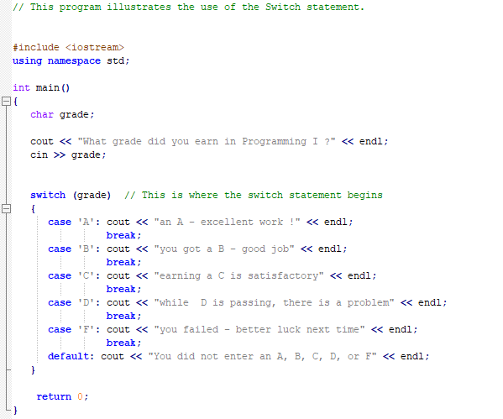

- Suppose that classStanding is a char variable, and gpa and dues are double variable. Write a switch expression that assigns the dues as following:

If classStanding is ‘f’, the dues are $150.00; if classStanding is ‘s’ ( if gpa is at least 3.75, the dues are $75.00; otherwise dues are 120.00); if classStanding is ‘j’ ( if gpa is at least 3.75, the dues are $50.00; otherwise, dues are $100.00); if classStanding is ‘n’ ( if gpa is at least 3.75, the dues are $25.00; otherwise, dues are $75.00).

Note that the code ‘f’ stands for first year students, the code ‘s’ stands for second year students, the code ‘j’ stands for juniors, and the code ‘n’ stands for seniors.

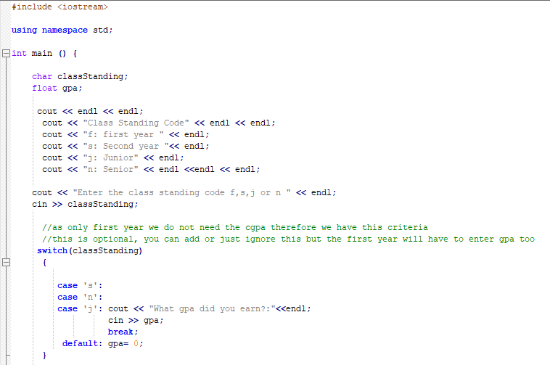

Continue..
